**Black Box Calculation**

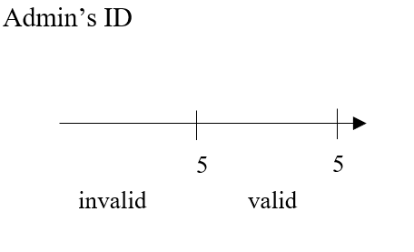

* ***EP***
* = 5
* ***Test Values***
* 5
* 4
* 6
* ***Boundary Values***
* = 5

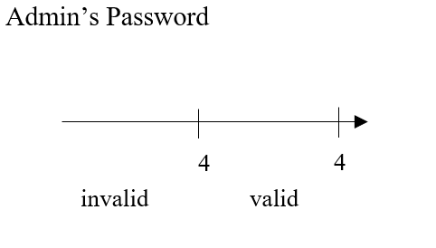

* ***EP***
* = 4
* ***Test Values***
* 3
* 4
* 5
* ***Boundary Values***
* = 4